**Lab 8**

**Name:** Trần Gia Khôi

**ID:** ITITIU21231

**Exercise 1: Project Setup & Entity**

**Task 1.1: Create Spring Boot Project**

Project created successfully

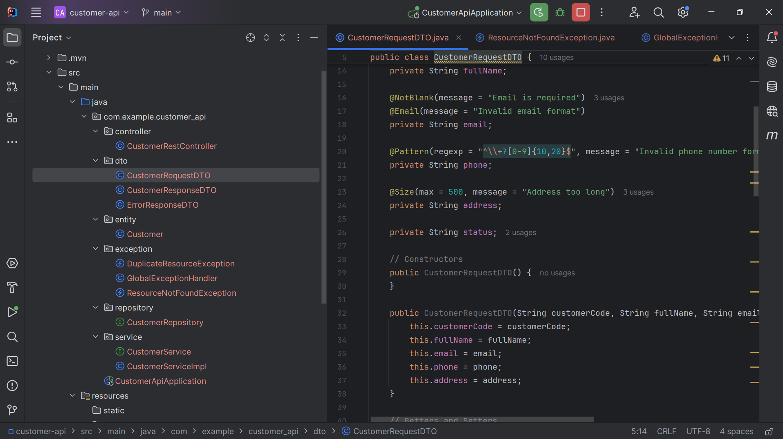

All dependencies added

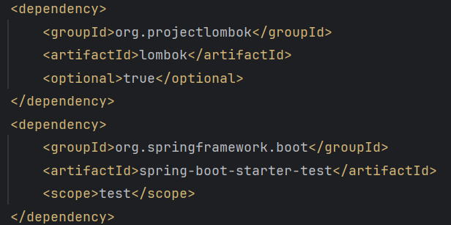

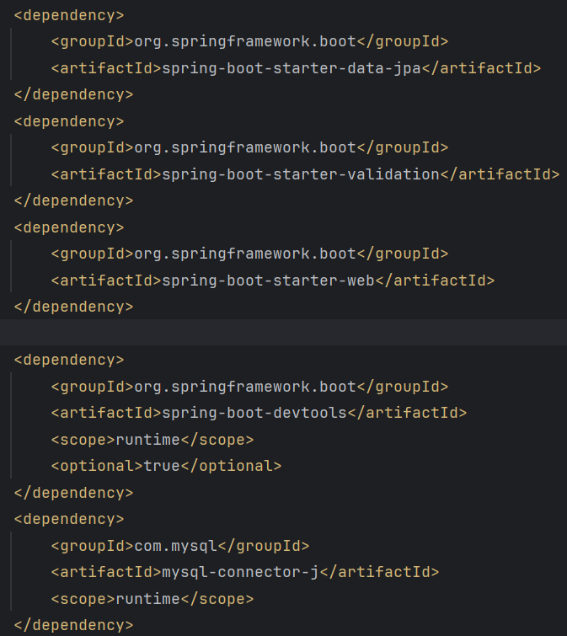

Project structure correct

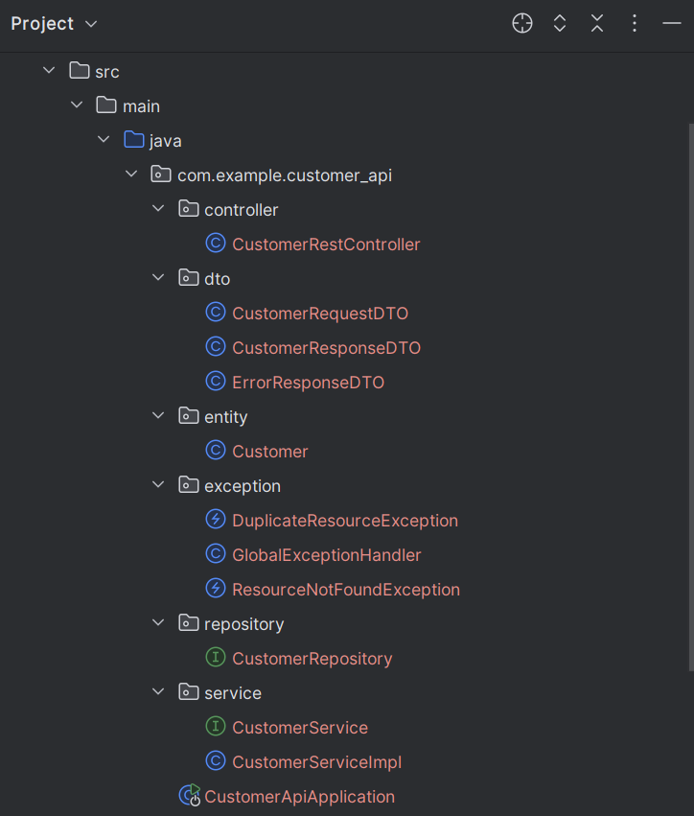

**Task 1.2: Database Setup**

Database created

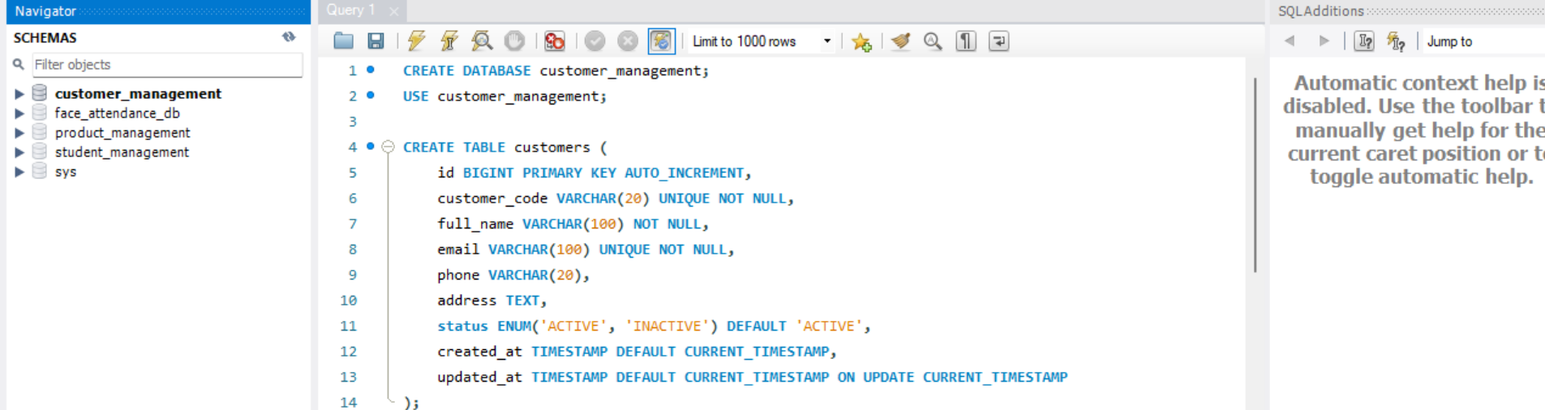

Database created with data

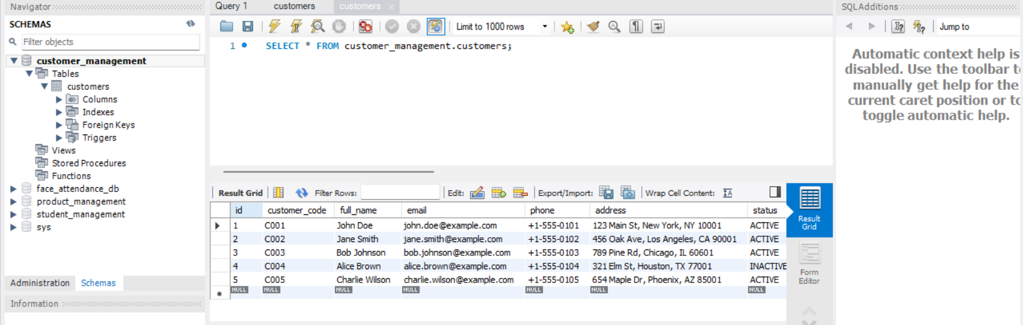

application.properties configured

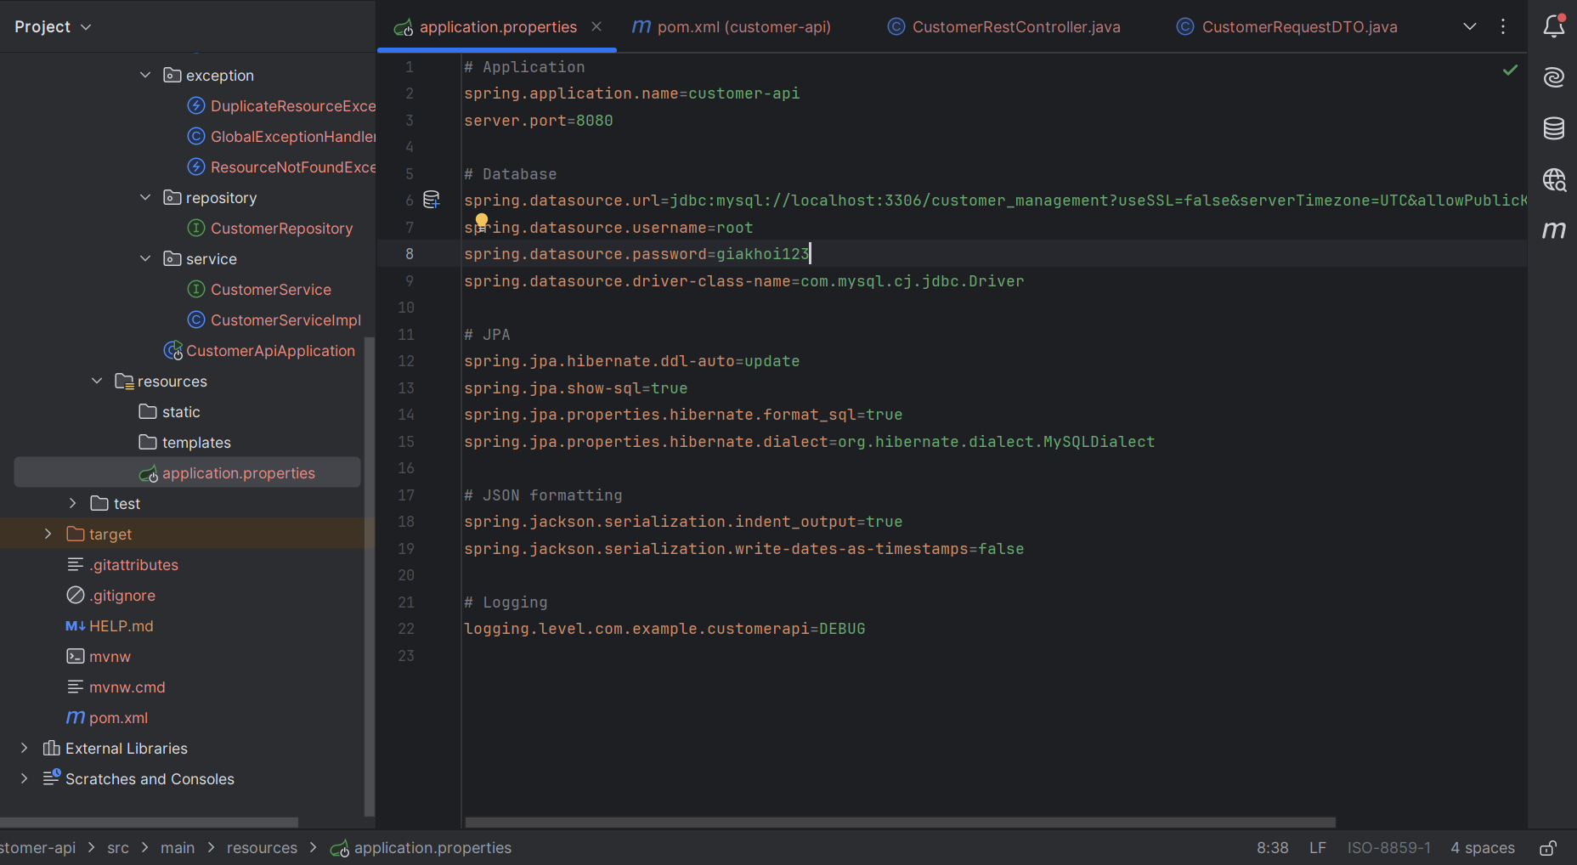

**Task 1.3: Create Customer Entity**

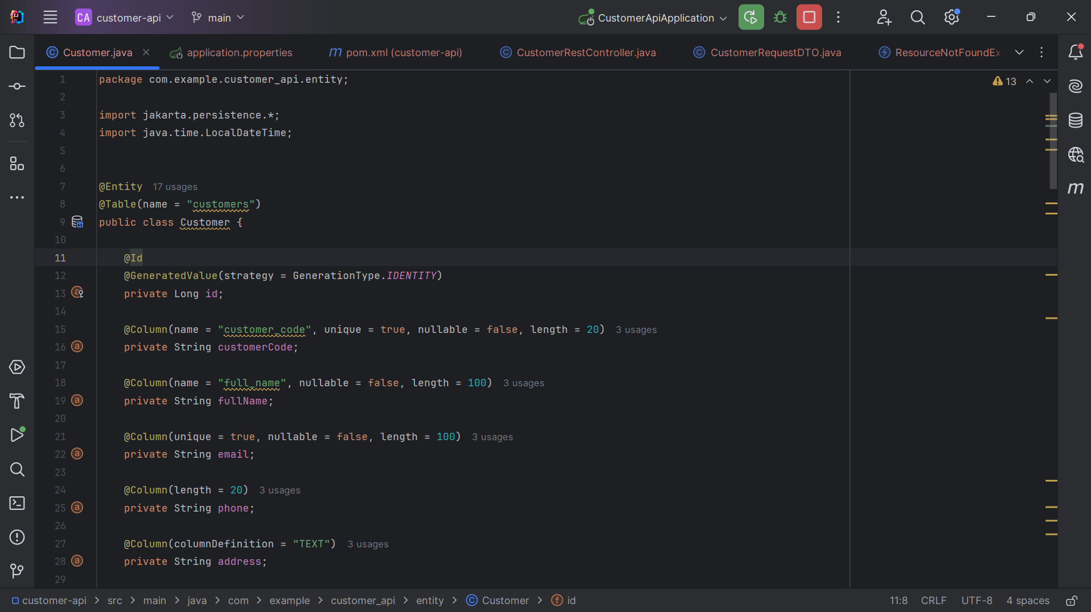

JPA annotations correct

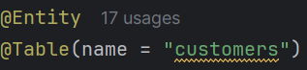

An “@Entity” annotation is used to defined a JPA entity that represents data that can be persisted in a database. A “@Table” annotation is used to specify the details of the table that will be used to persist an entity in the database.

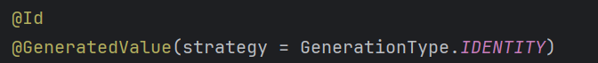

An “@Id” annotation is a key component of JPA and is used to designate the primary key of an entity. A “@GeneratedValue” annotation is used in conjunction with the “@Id” annotation to automatically generate unique values for primary key columns in a database tables.

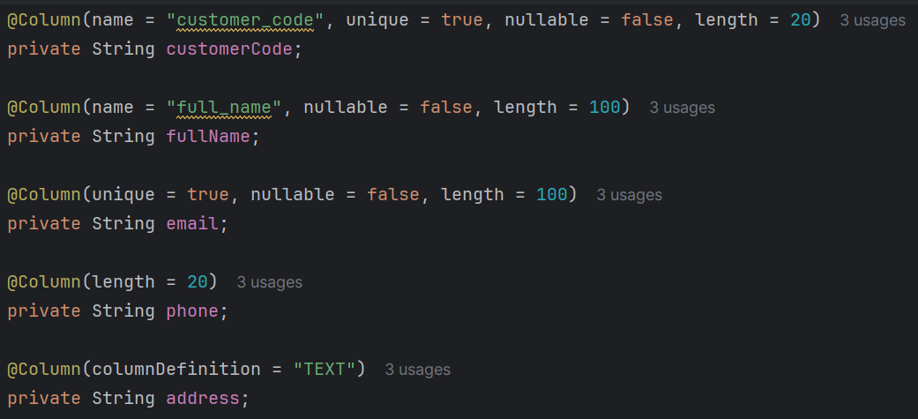

A “@Column” annotation is used to customize the mapping of Java class fields to database columns.

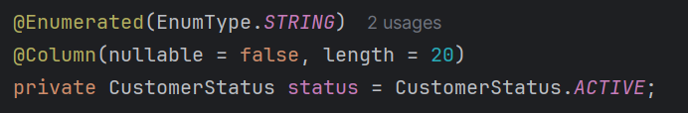

Lifecycle callback

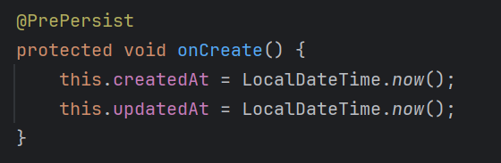 A “@PrePersist” is used to define a method that should be executed before an entity is persisted into the database.

Getters/setters complete

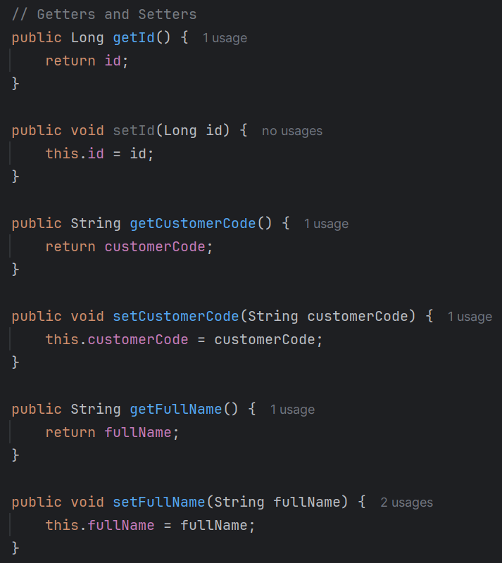

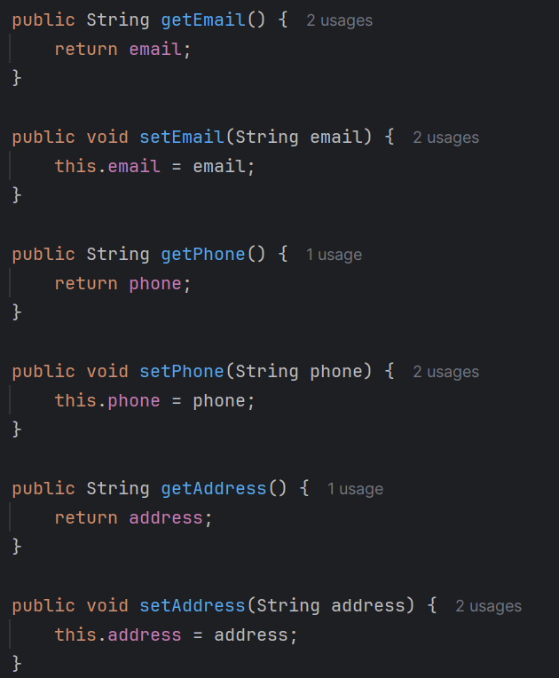

Enum created

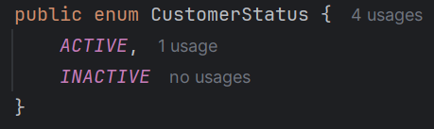

An enum is created to define the status of customer, which has two values, *ACTIVE* and *INACTIVE.*

**Checkpoint #1:**

Entity mapping:

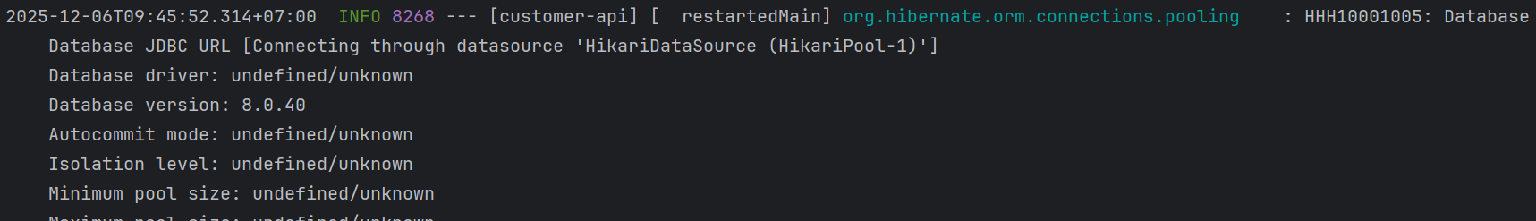

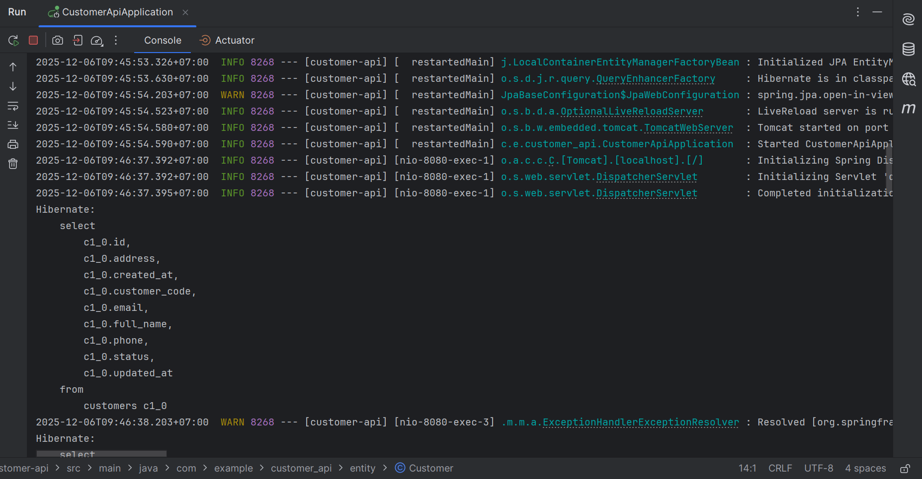

**Exercise 2: DTO Layer**

**Task 2.1: Create Request DTO**

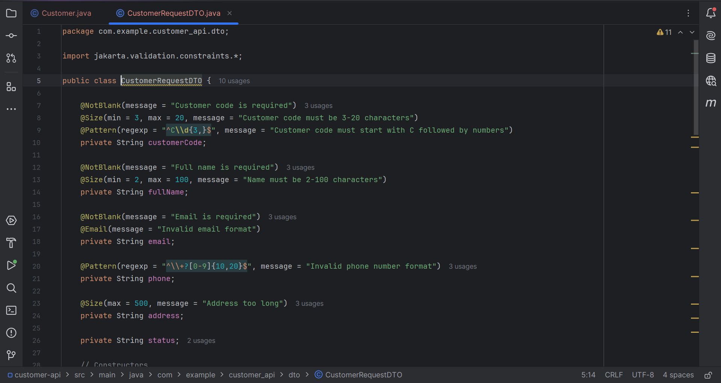

All validation annotations correct



A “@NotBlank” annotation is a validation constraint used to ensure that a String field is not null. A “@Size” annotation is used to validate the size of various types of elements. A “@Pattern” is used for validating string fields against a regular expression.



A “@Email” is used for validating an email field.

Constructors and getters/setters

Constructors:

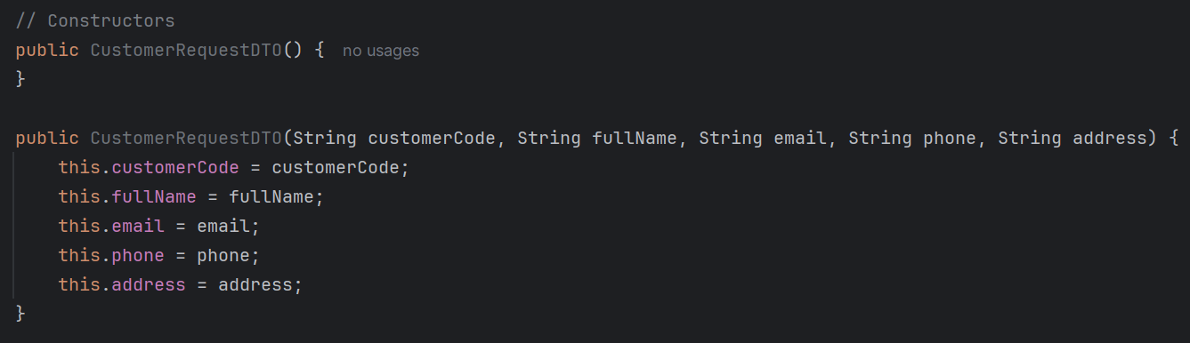

Getters/setters

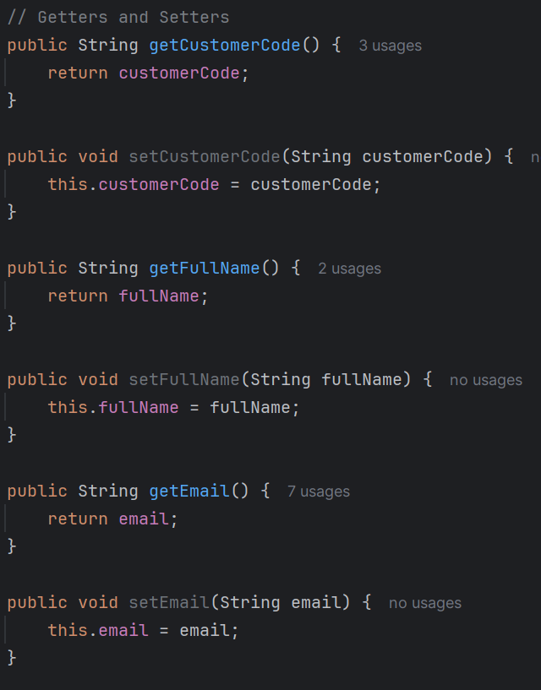

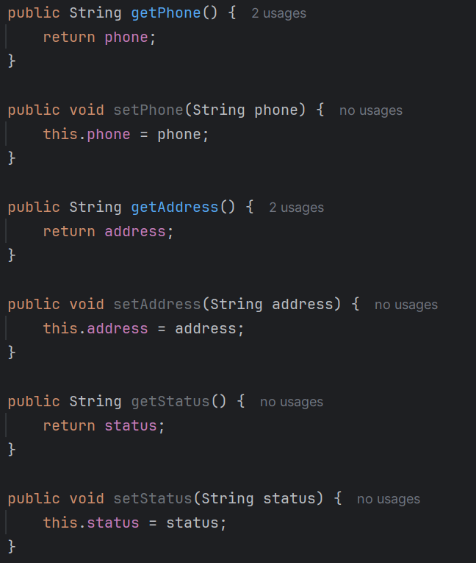

There is no ID field for this class since we use this class to validate the field. And ID is a primary key, which is the field that will be fixed and we do not have permission to touch and modify it.

**Task 2.2: Create Response DTO**

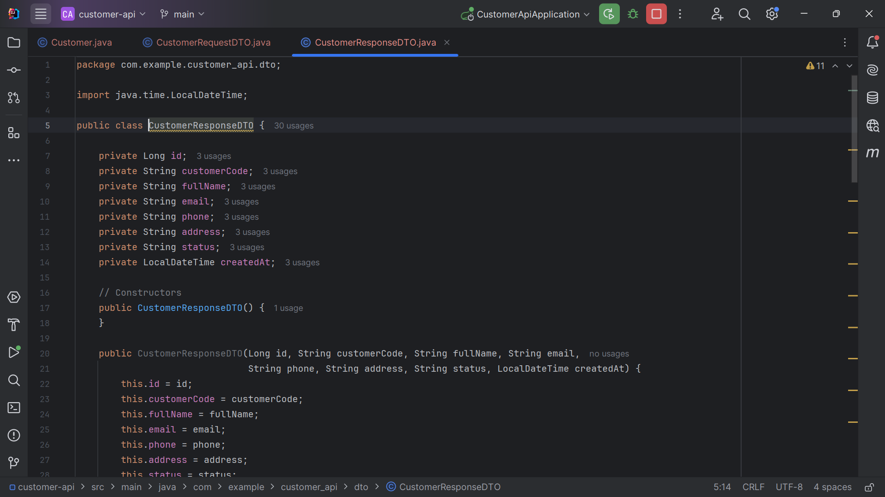

All responses fields present with proper data types used

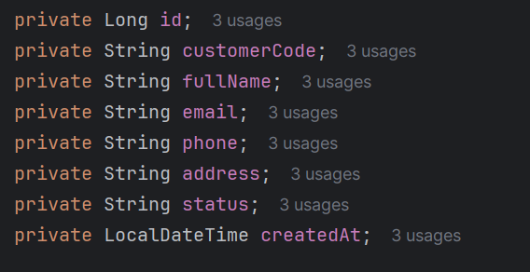

Constructor and getters/setters

Constructors:

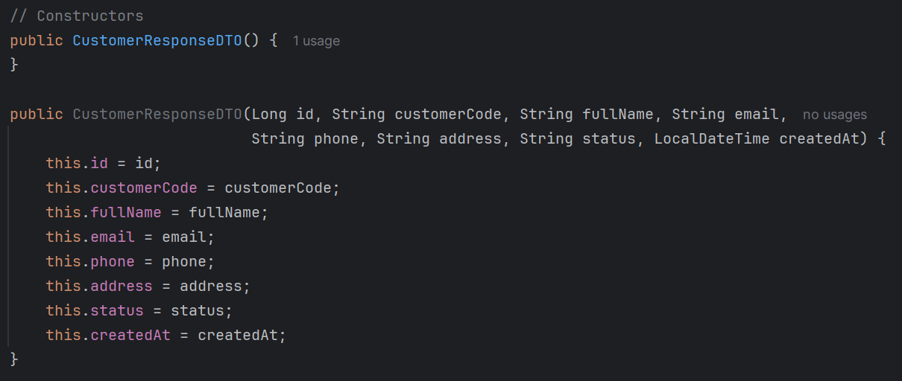

Getters and setters

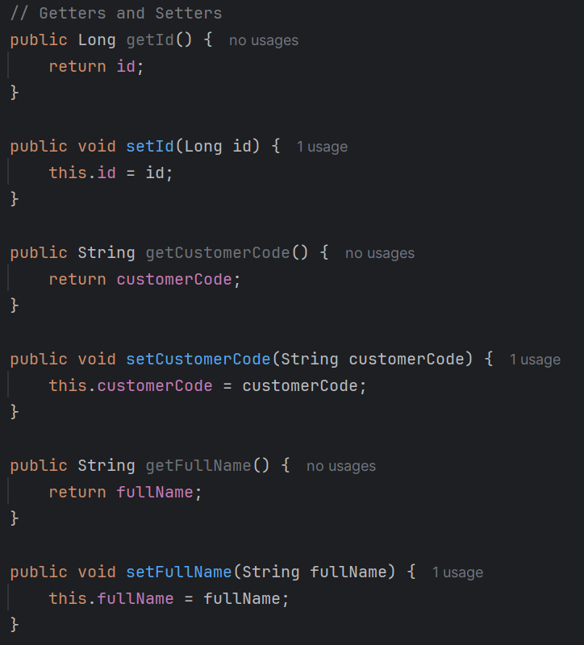

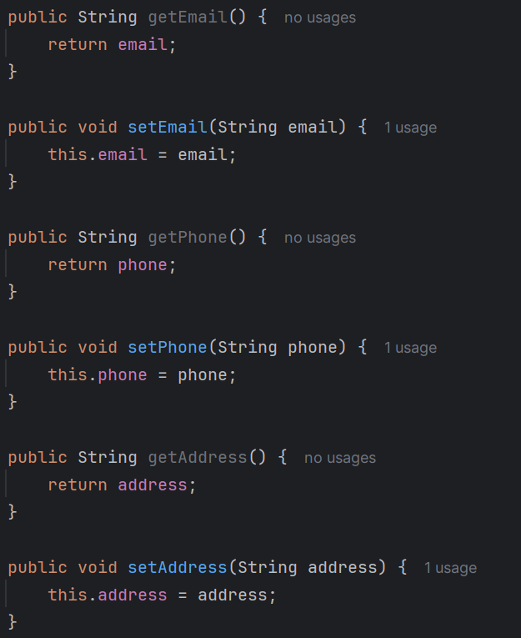

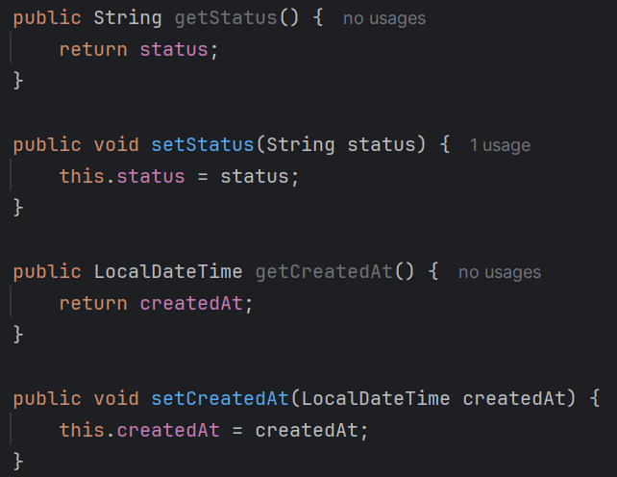

**Task 2.3: Create Error Response DTO**

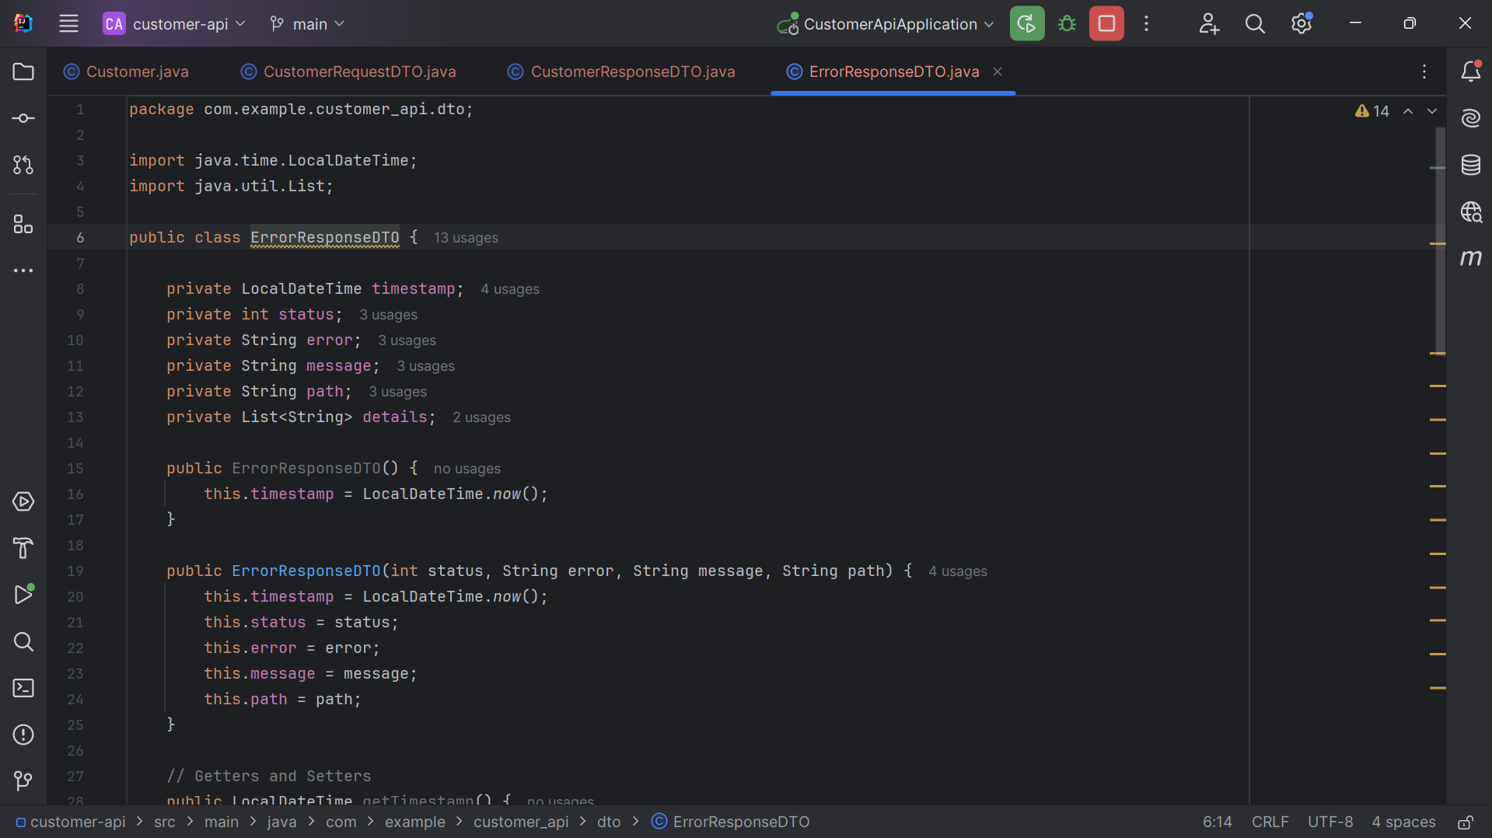

All error fields present

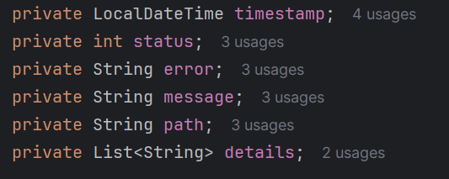

Timestamp auto-generated

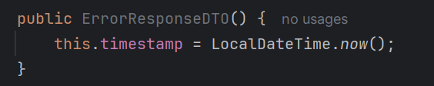

Getter and setters

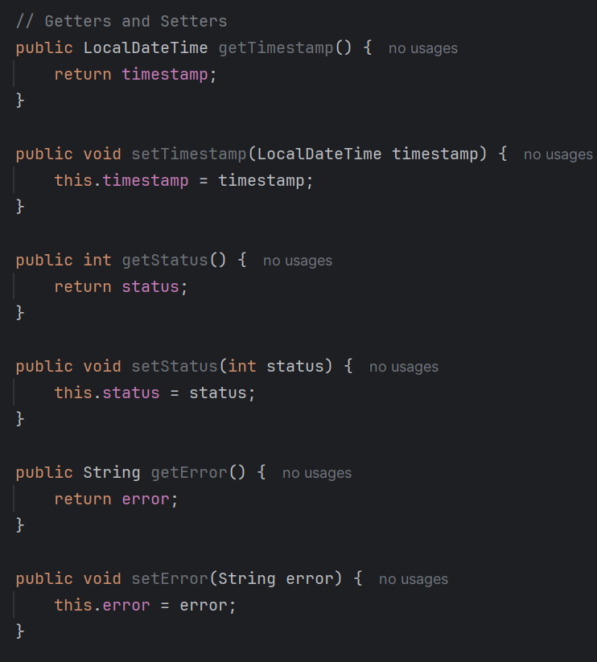

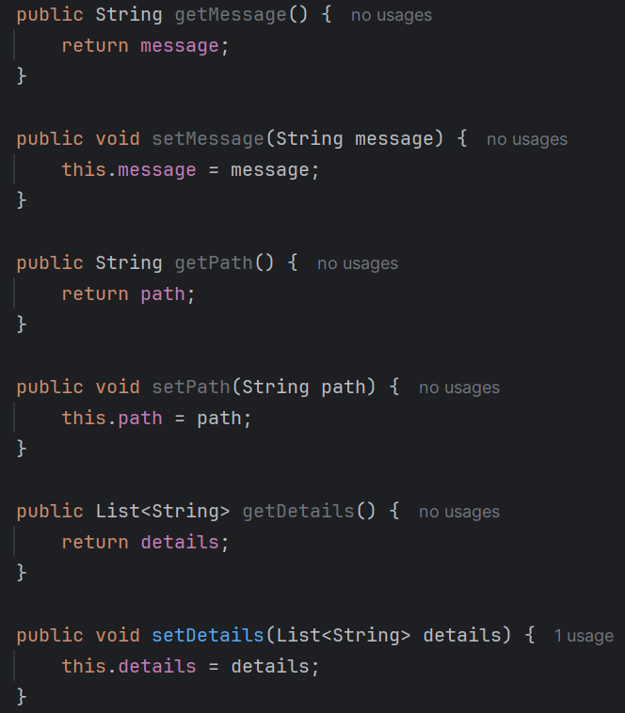

**Exercise 3: Repository & Service**

**Task 3.1: Create Repository**

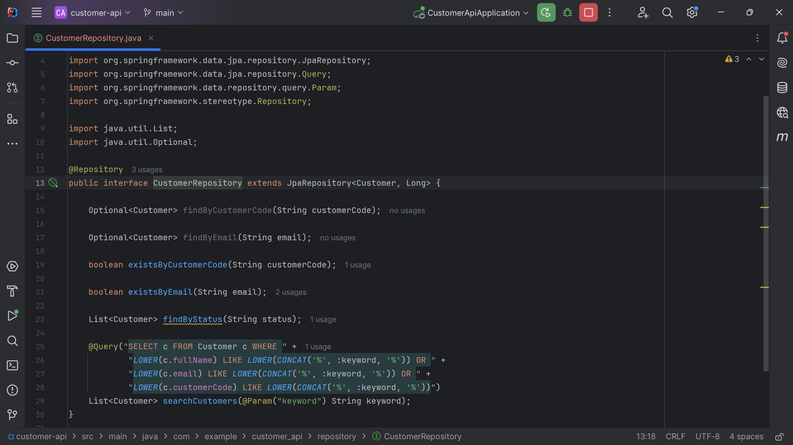

Repository extends JpaRepository



Custom methods defined

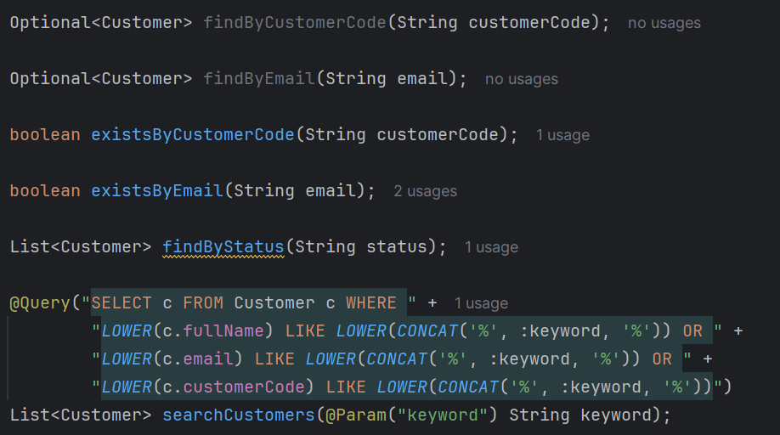

**Task 3.2: Create Service Interface**

CustomerService is created as interface

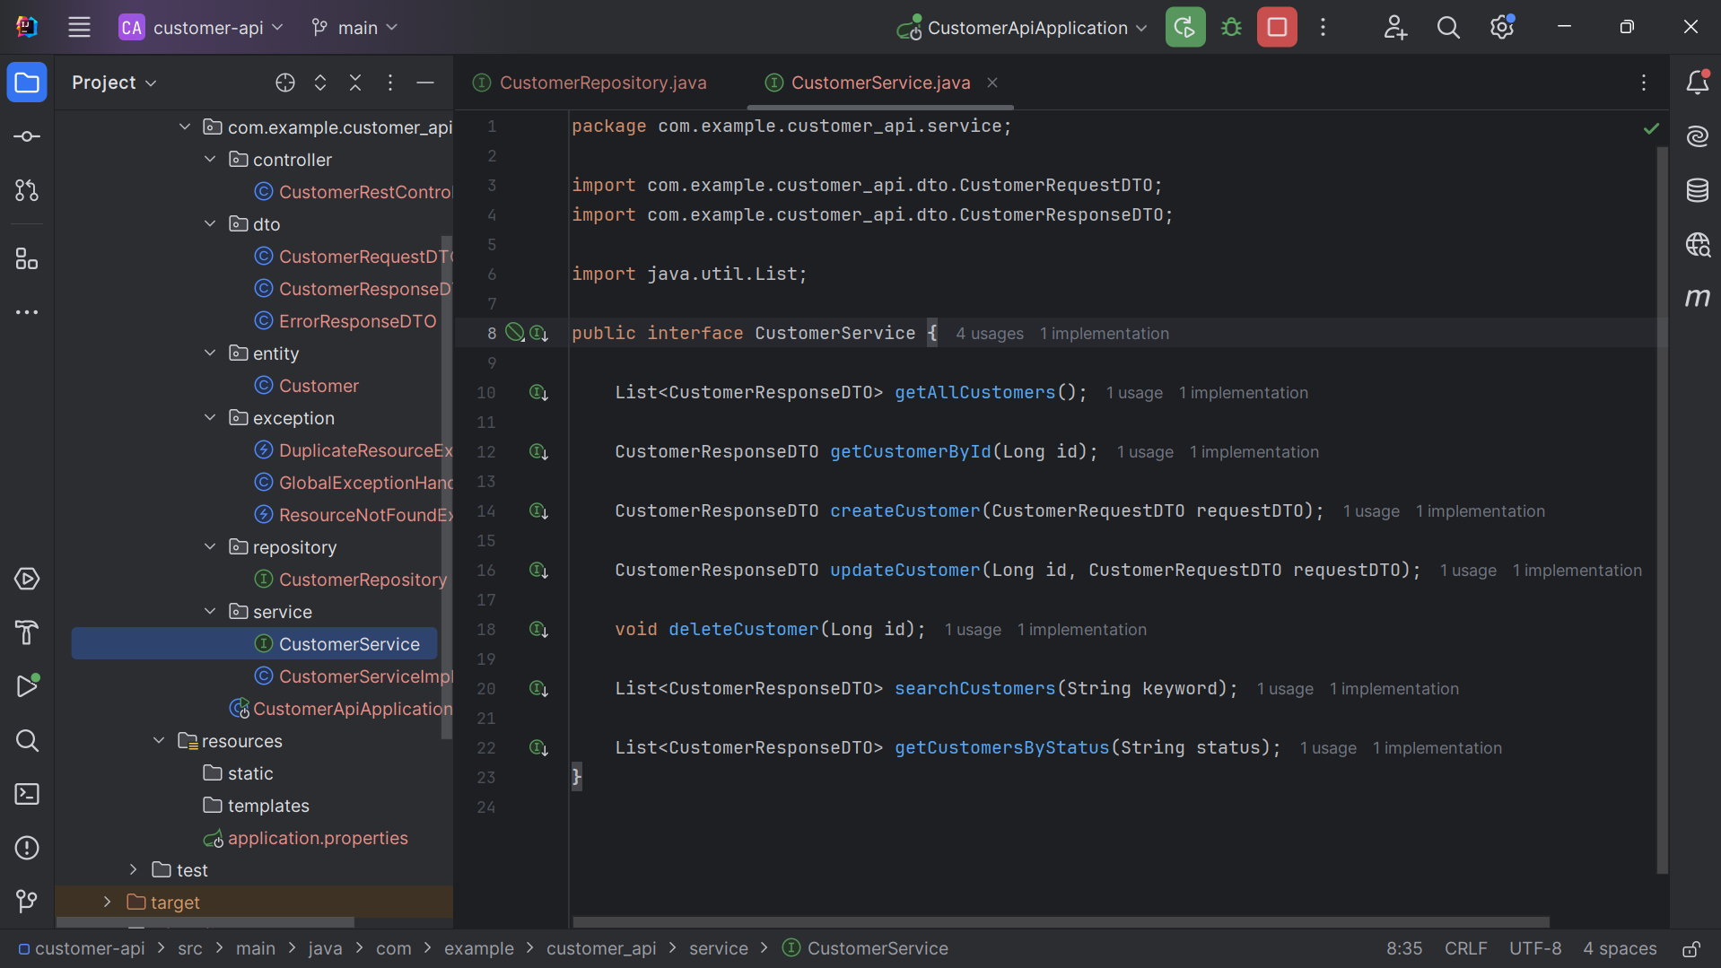

**Task 3.3: Implement Service**

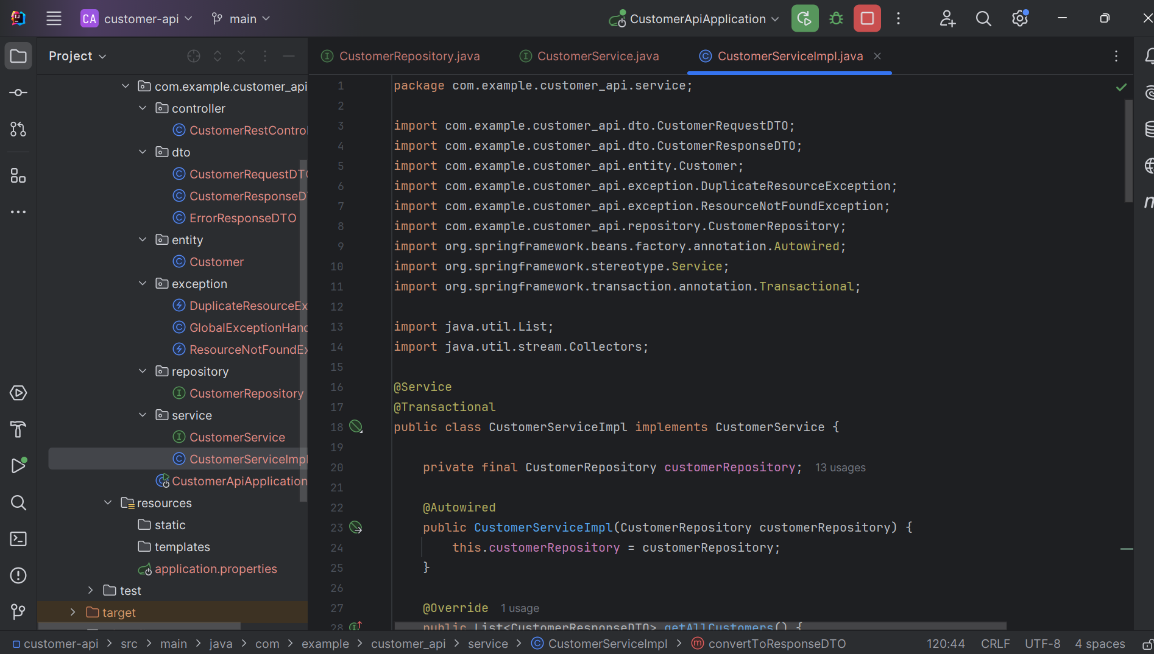

All CRUD methods implemented

getAllCustomers()

This method will return a list of customers

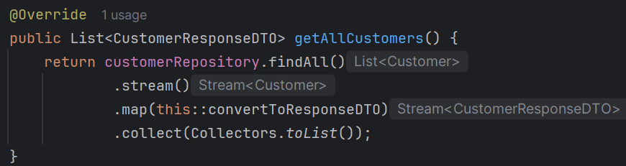

getCustomerById()

This method will return a customer by searching his/her id

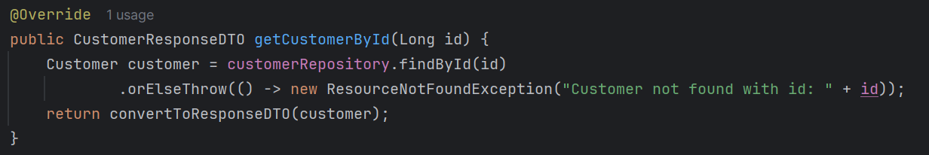

createCustomer()

This method will create customer with desired field from **Customer** entity

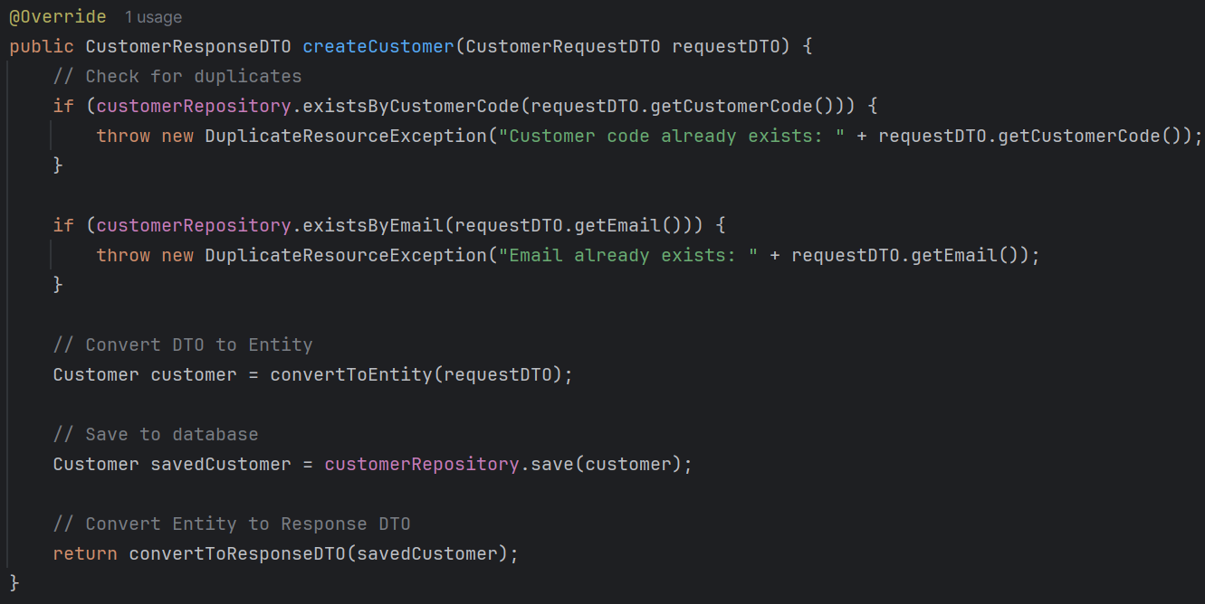

updateCustomer()

This method will update customer by finding his/her id and update specific fields (fullName, email, phone and address)

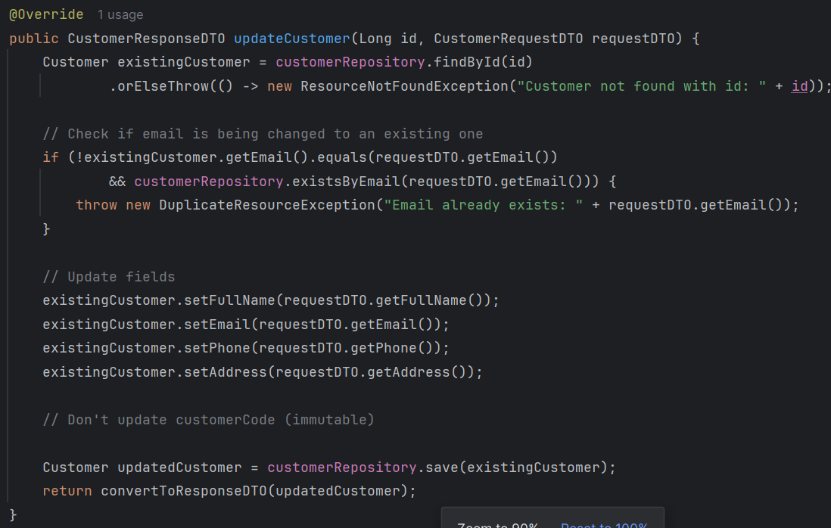

deleteCustomer()

This method will be used to delete customer

searchCustomer()

This method will search customer with provided keyword

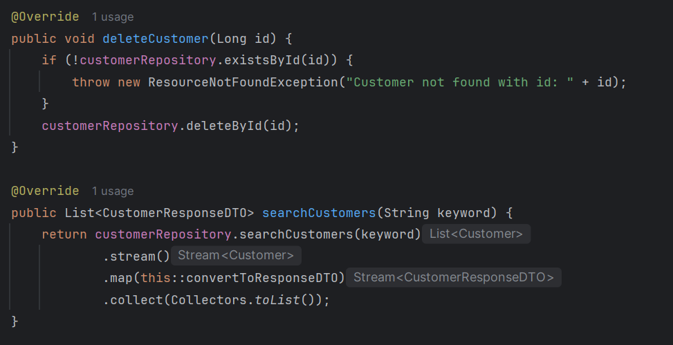

getCustomersByStatus()

This method will get customer by searching through his/her status (ACTIVE or INACTIVE)

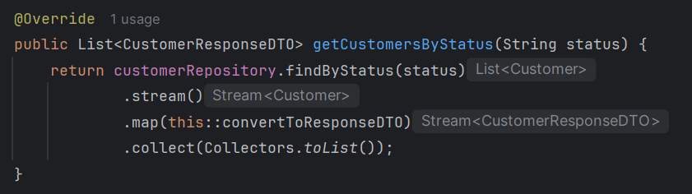

DTO conversion methods work

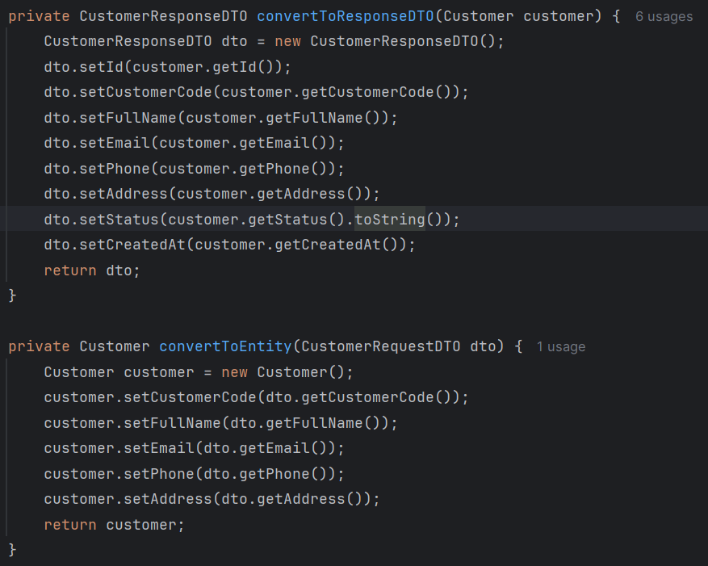

These two methods will be used for converting.

convertToResponseDTO() will take type **Customer** as its parameter and convert to type **CustomerResponseDTO.**

convertToEntity() will take type **CustomerRequestDTO** as its parameter and convert to type **Customer.**

**Exercise 4: Rest Controller**

**Task 4.1: Create Basic REST Controller**

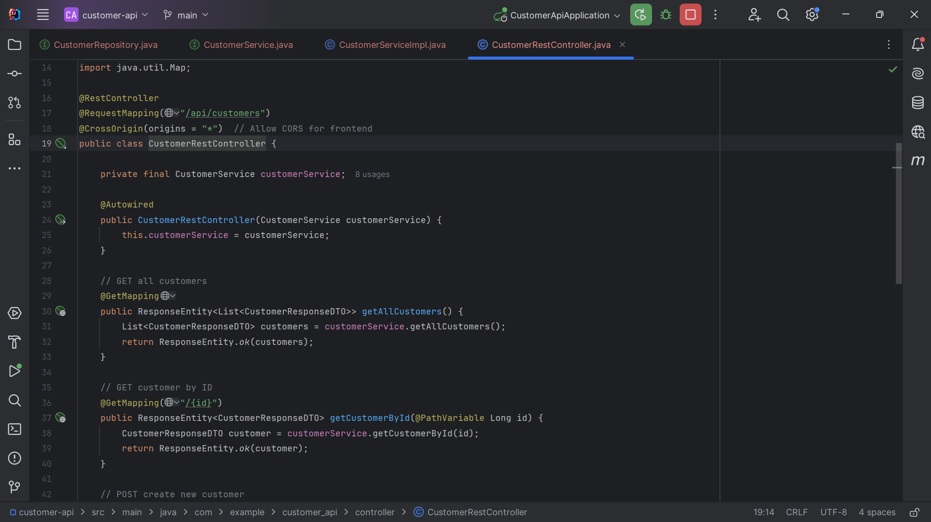

@RestController configured

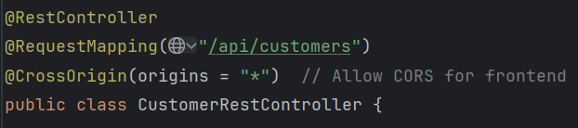

A “@RestController” is designed for building RESTful web services

GET all endpoint works

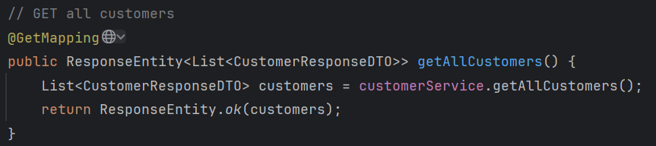

Testing in Postman:

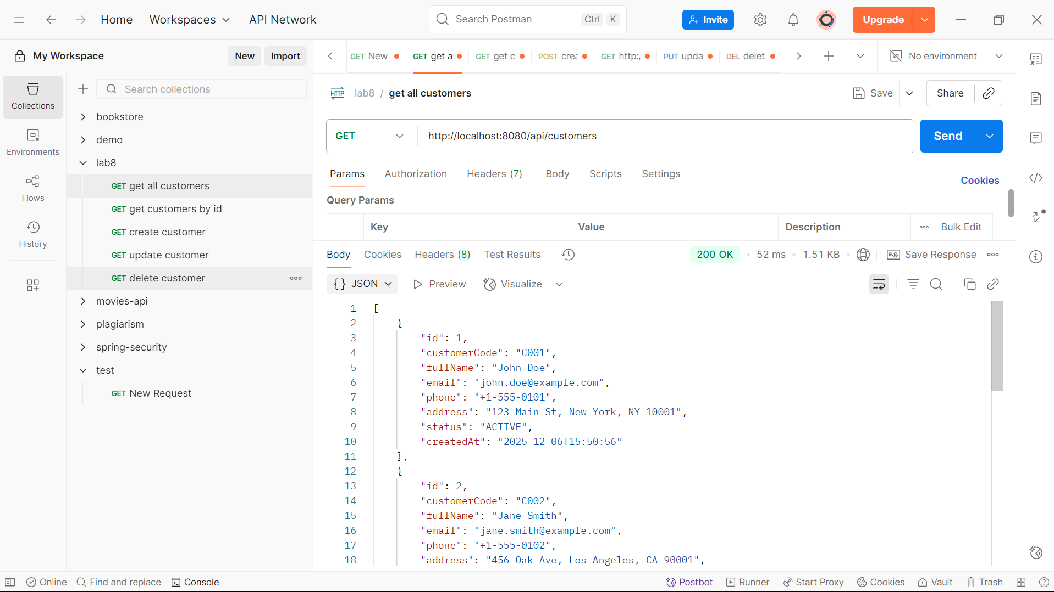

GET by ID endpoint works

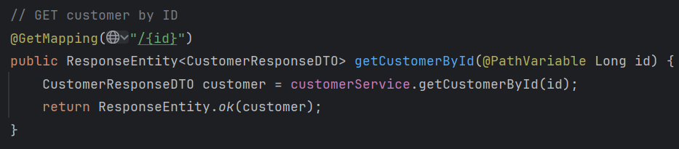

Testing in Postman:

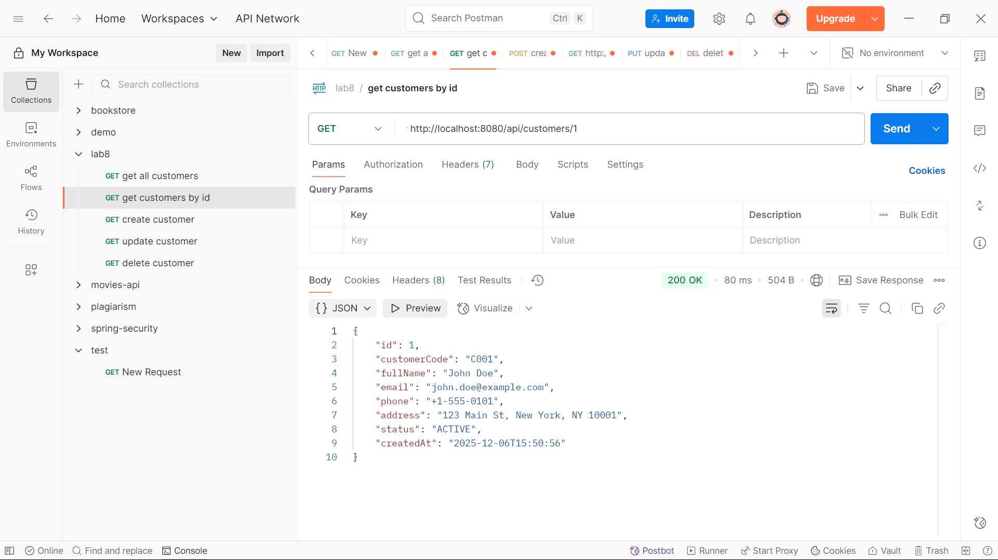

POST create endpoint works

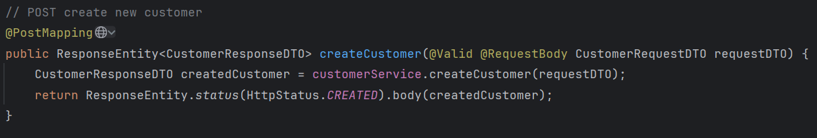

Testing in Postman:

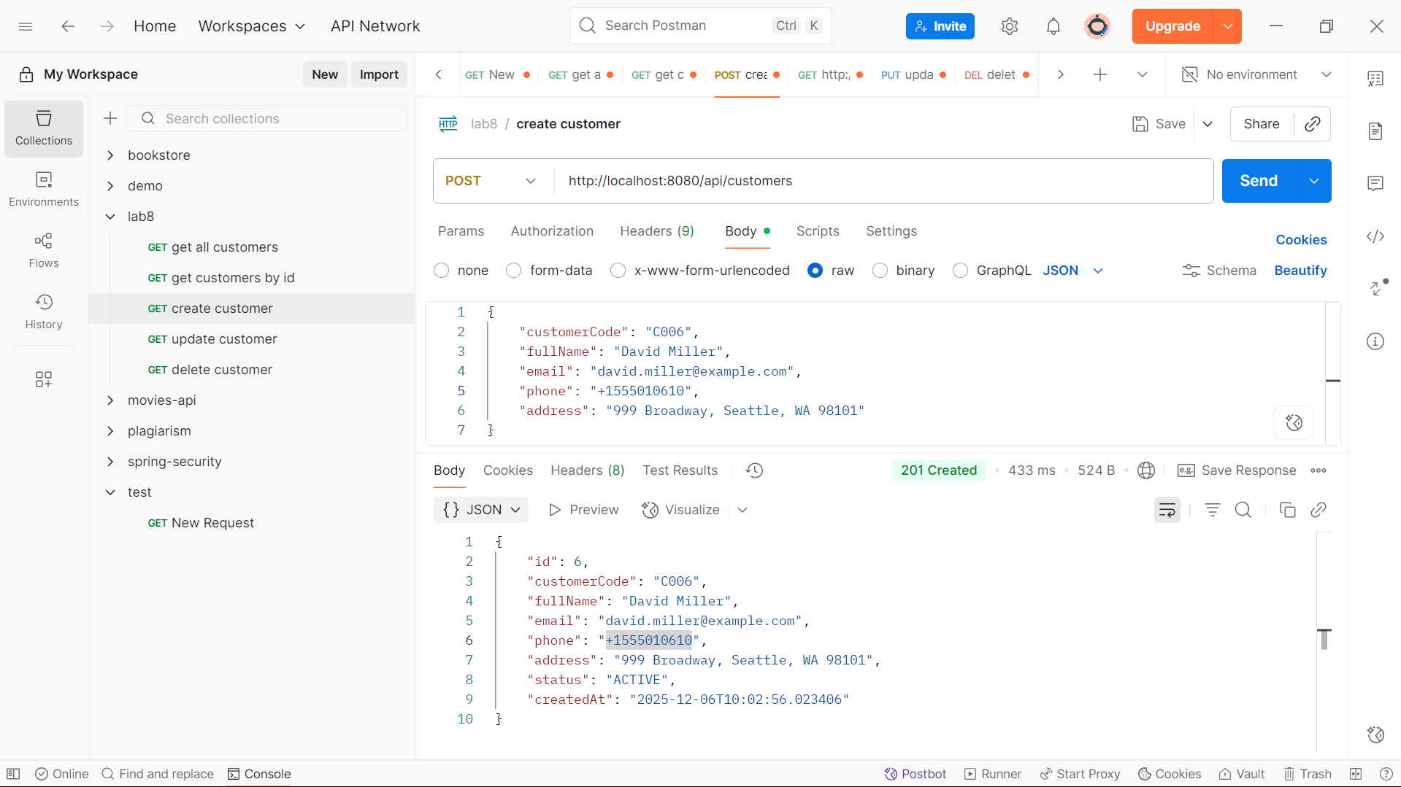

PUT update endpoint works

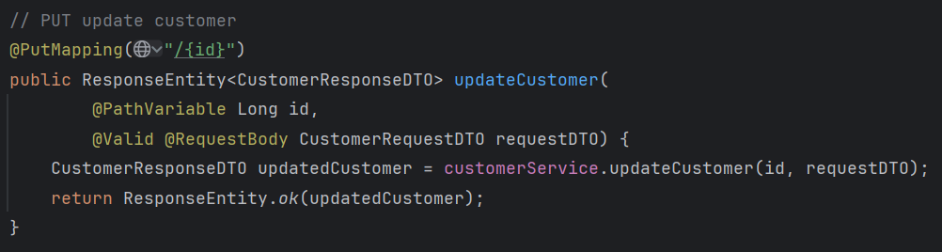

Testing in Postman:

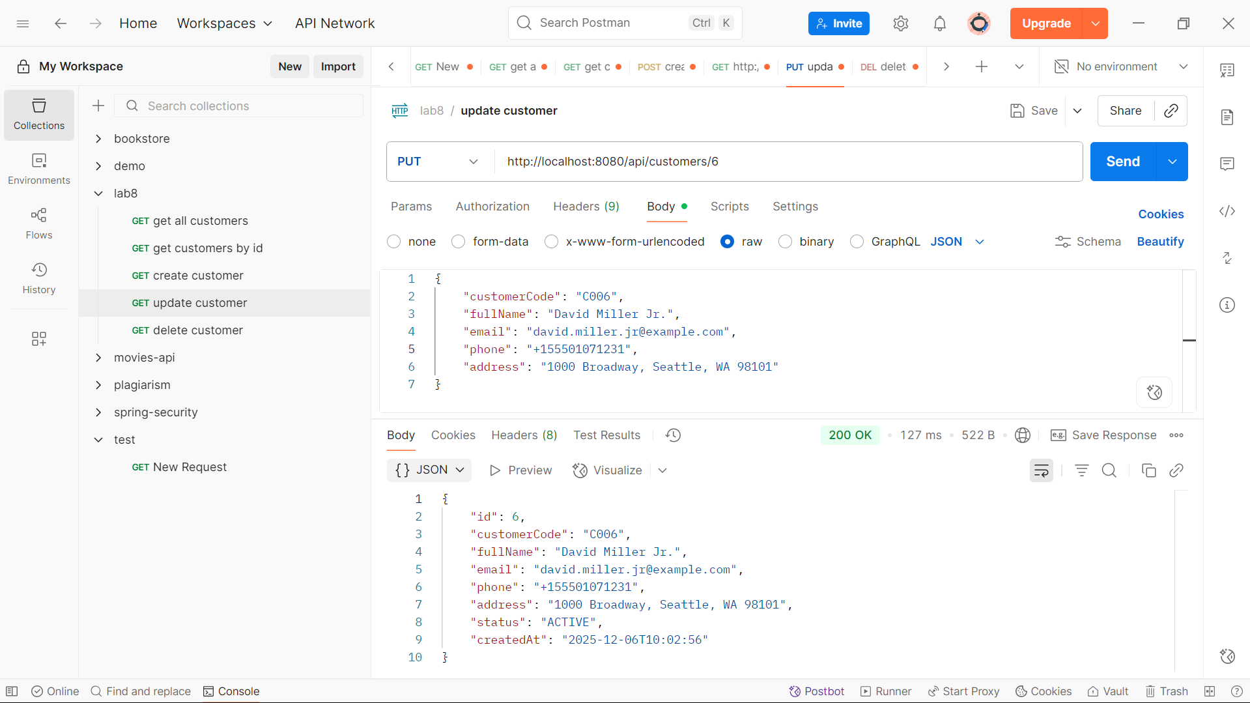

DELETE endpoint works

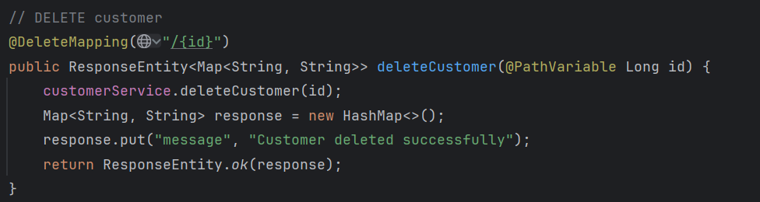

Testing in Postman:

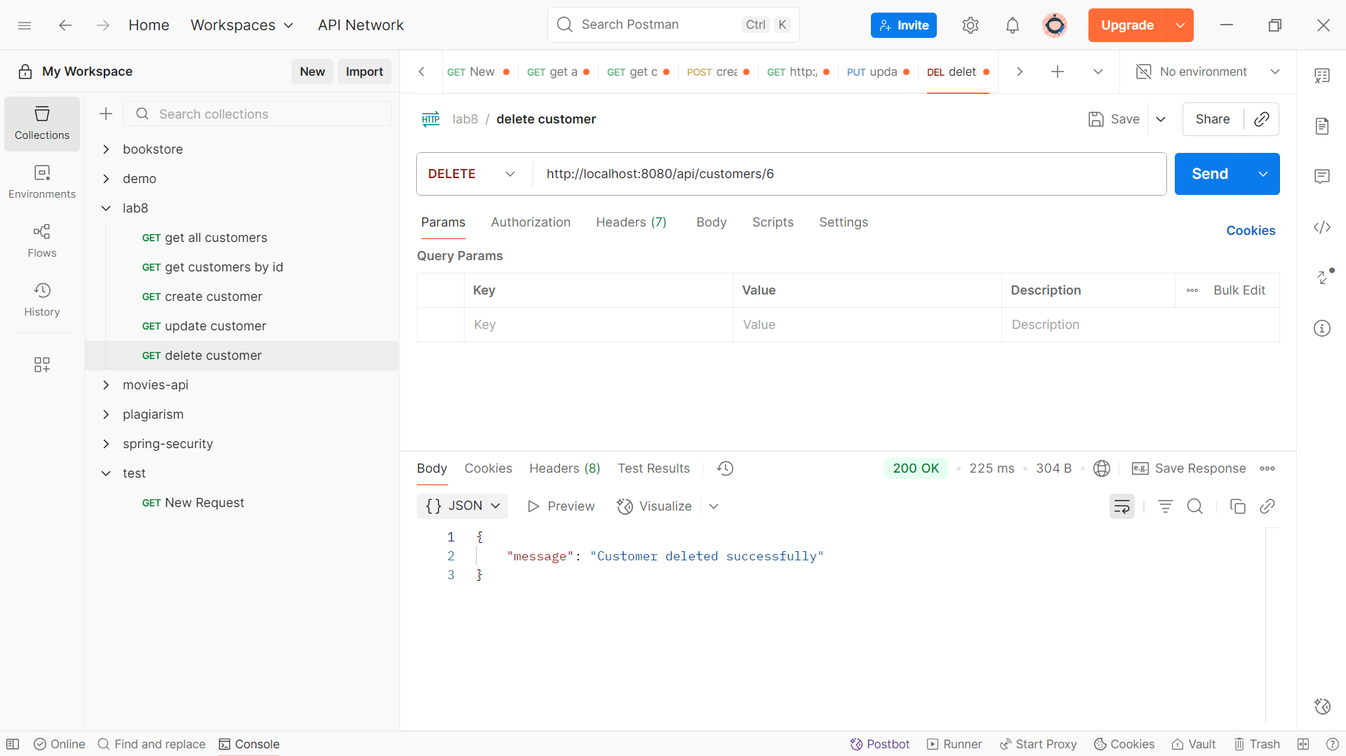

**Task 4.2: Add Exception Handling**

ResourceNotFoundException created

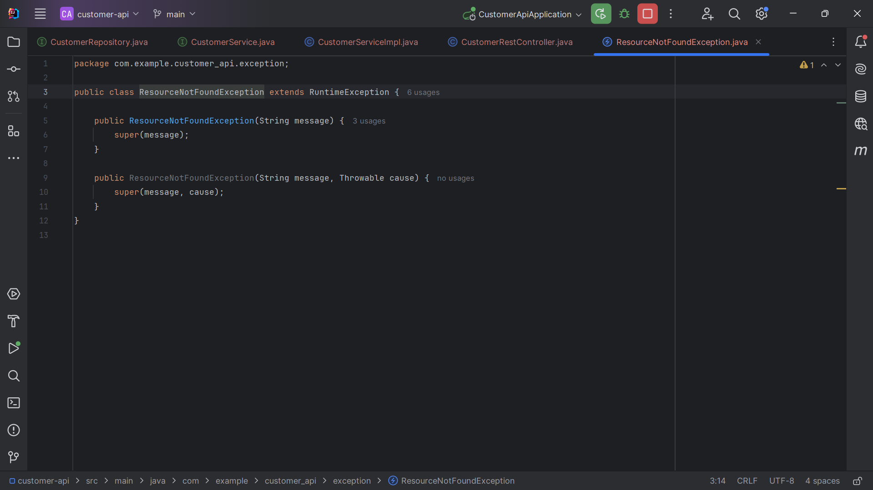

DuplicateResourceException created

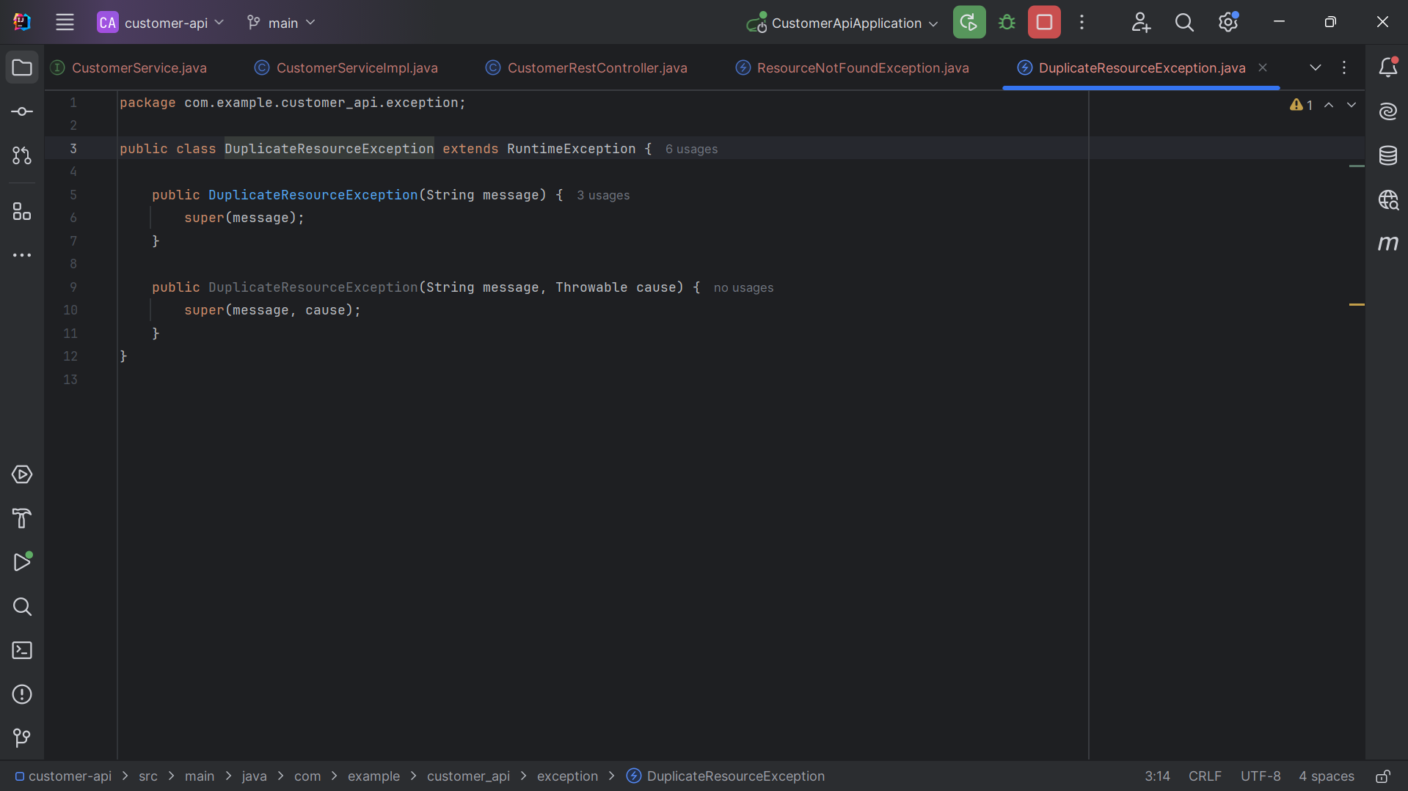

GlobalExceptionHandler created

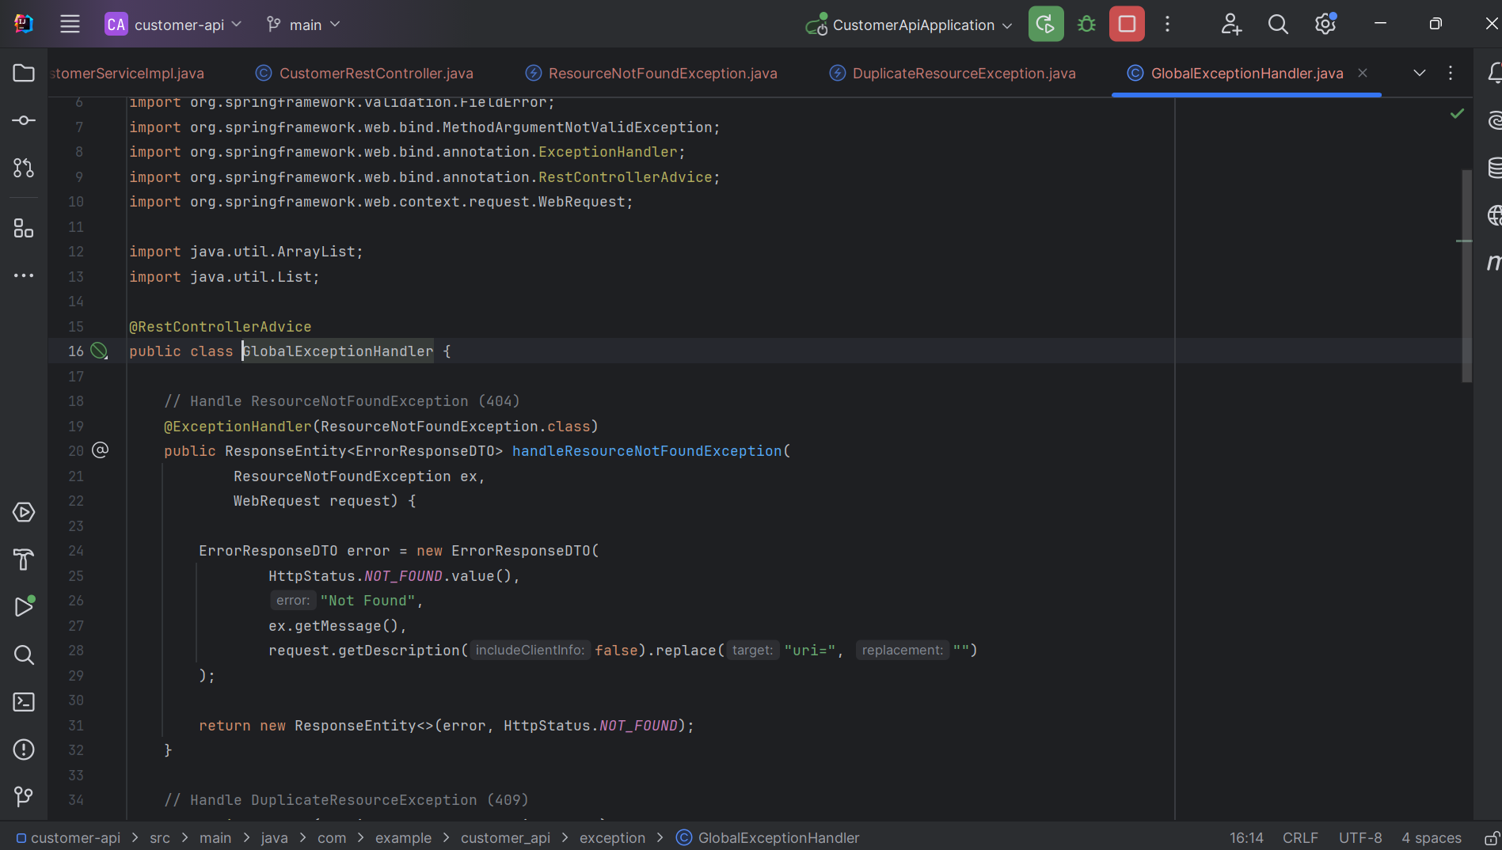

@RestControllerAdvice configure

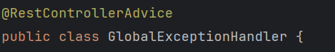

A “@RestControllerAdvice” is a specialized annotation for global exception handling in RESTful web services.

ResourceNotFoundException handler

This handler will handle the popular error, which is “404 Not Found”

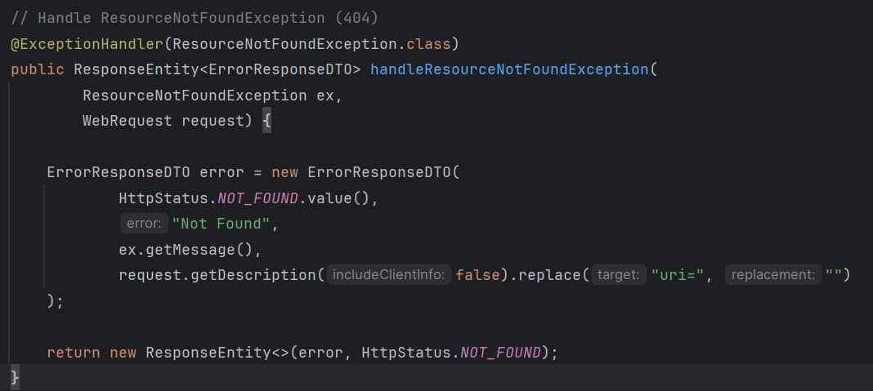

DuplicateResourceException handler

This handler will handle the conflict between resources, which is response 409

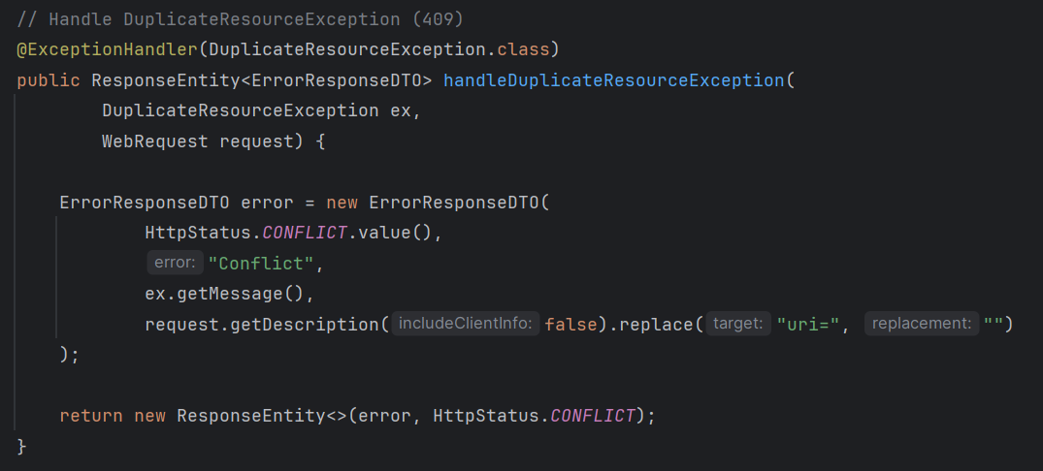

Validation exception handler

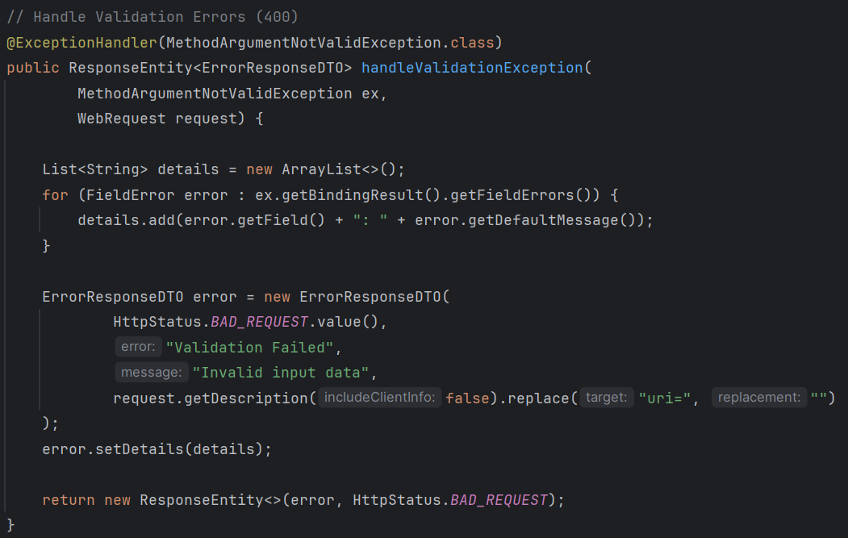

This handler will handle the validation error, which is the response “400 Bad Request”

**Workflow:**

**Get all customers**

1. Browser 🡪 GET /api/customers

2. CustomerRestController receives request (@GetMapping)

3. Controller calls customerService.getAllCustomers()

4. Service calls customerRepository.findAll()

5. JPA automatically queries database

6. Repository returns List<Customer>

7. Service will convert each Customer to CustomerResponseDTO

8. Then put each object (CustomerResponseDTO) to a List and return to Controller

9. Controller response with a list of CustomerResponseDTO

**Get customer by ID**

1. Browser 🡪 GET /api/customers/{id}

2. CustomerRestController receives request (@GetMapping)

3. Controller calls customerService.getCustomerById()

4. Service calls customerRepository.findById()

5. JPA automatically queries database

6. Repository returns Customer

7. Service will convert Customer to CustomerResponseDTO and return to Controller

8. Controller response with a CustomerResponseDTO

**Create customer**

1. Browser 🡪 POST /api/customers

2. CustomerRestController receives request (@PostMapping)

3. Controller calls customerService.createCustomer()

4. Service calls customerRepository.save()

5. JPA automatically queries database

6. Repository returns Customer

7. Service will convert Customer to CustomerResponseDTO and return to Controller

8. Controller response with a CustomerResponseDTO

**Update customer**

1. Browser 🡪 PUT /api/customers/{id}

2. CustomerRestController receives request (@PutMapping)

3. Controller calls customerService.updateCustomerById()

4. Service calls customerRepository.findById() and customerRepository.save()

5. JPA automatically queries database

6. Repository returns Customer

7. Service will convert Customer to CustomerResponseDTO and return to Controller

8. Controller response with a list of CustomerResponseDTO

**Delete customer**

1. Browser 🡪 DELETE /api/customers/{id}

2. CustomerRestController receives request (@DeleteMapping)

3. Controller calls customerService.deleteCustomer()

4. Service calls customerRepository.deleteById()

5. JPA automatically queries database

6. Controller create a HashMap with “message” as *key* and “response” as *value*

7. Controller return HashMap